Enrichment Paper:
The Impact of the Missions on
Native Americans and Agriculture in California

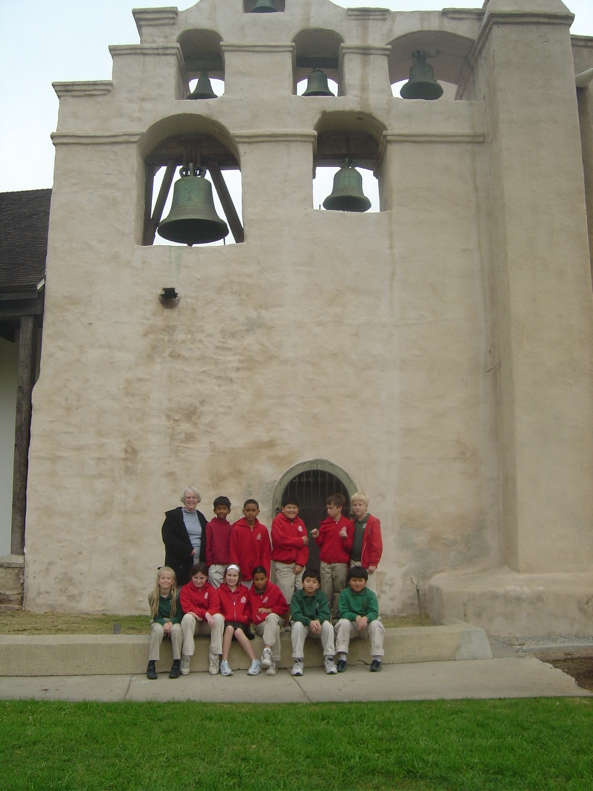

Figure 1. San Gabriel Arcangel Mission with Anita Oaks School (Palmer, 2007).

History of American Agriculture

Master Sustainable Food Systems, Green Mountain College
Sharon Palmer
June 30, 2017
Introduction

As a California resident of 35 years, I have always been drawn to the state’s unique agricultural history, which commenced with the Native American tribes who lived off the land here for at least 10,000 years before the Spanish set up Missions and agriculture in 1769. In the thriving metropolis of Los Angeles in which I reside, it’s hard to imagine that natives once harvested acorns from the ancient live oak tree in my front yard, and fished for salmon that once choked the nearby San Gabriel River. When my children entered fifth grade, they studied the Mission era in their history classes (Fig. 1). I traveled with them to many Missions, learning about the sad fate that befell the Native Americans. This happened right in my bioregion; the San Gabriel Arcangel Mission is located only 11 miles from my home.

Native American Life in California Before the Missions
Long before the Spanish arrived, the Native Americans lived in hundreds of small groups across what we call California today, speaking more than 100 languages, and developing religious systems, social norms, and trading for goods and services (Dutschke, 2014). They lived in balance with nature and the rhythm of the seasons, spending only 10 - 15 hours per week hunting and gathering all the essentials for food and clothing. Starvation was unknown, and they had no need for agriculture; only a few tribes in southern California practiced it. Instead the natives relied upon the cornucopia of natural resources: fresh fish (the predominant protein, including salmon, trout, and eel), seafood (clams, mussels, and crabs), insects (grasshoppers, crickets, caterpillars, earthworms, and flies), sea animals (seals, sea lions, and sea otters), birds (quail, grouse, and water birds), small game (rabbits, rats, squirrels, mice, and chipmunks), large game (deer, elk, antelope, mountain sheep, and bear), and edible plants (acorns, mushrooms, seaweed, flowering plants, seeds, berries, nuts, leaves, stems, and roots) (Mullen, 2003; Glass). The first explorers found the landscape throbbing with living things, with creatures so unguarded and abundant they were almost a nuisance (Hemingway, 1996).
The natives invented methods to take advantage of the abundant resources, such as snares, decoys, and weapons for hunting, and techniques to turn acorns into a versatile food staple for flour, bread, soups, and mush. They had a well balanced diet that took little physical labor. The gathering and preparing of food became a key social and religious aspect of their daily lives. The women gathered and processed the plants and set aside food stores, while the men hunted fish and game (Hemingway, 1996).

Enter the Spanish and the Mission Era
While attempting to find the Northwest Passage, Juan Rodriquez Cabrillo was the first European to arrive in California, sailing under the Spanish flag in 1542. He found the California coast and claimed it for Spain (Dutschke, 2014). The natives were confused by the Spanish visitors, but did not perceive danger; they were excited about interacting with strangers bearing gifts, including glass beads, cloth and metal—items they’d never seen before (Hemingway, 1996).
The Spanish missionaries arrived to "Alta California" in the late eighteenth century, eventually building and operating 21 Missions along the coast from San Diego to Santa Rosa (Fig. 2) during 1769 to 1834. The goal of the Missions was to establish a military, economic, political, and religious basis for the Spanish Empire. At the time that the first Mission was founded, about 310,000 Native Americans lived in California. The Franciscan missionaries converted the native population (Fig. 3), regarding them as subjects of the Crown and capable of receiving sacraments of Christianity, and used them as a free, expendable workforce in the Missions (Heizer, & Whipple, 1971).

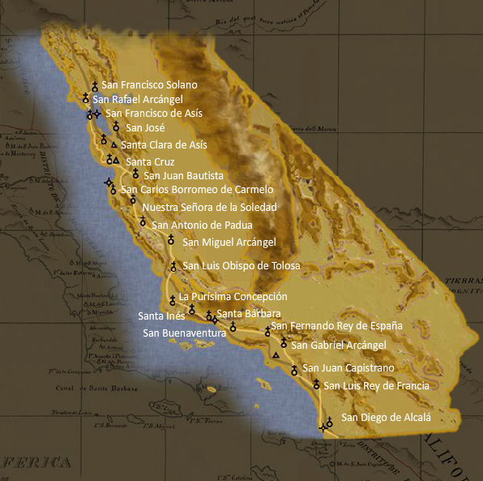

Figure 2. Map of the California Missions (California Missions Center).

At first, the natives came willingly to the Missions, drawn by curiosity. One intriguing study concluded that Native Americans were motivated to enter the Missions due to the spread of disease and destruction of food sources caused by newly introduced livestock, making it hard to sustain their traditional way of life (Jackson, & Gardzina). Most of the natives were forcibly captured by Spanish soldiers, and once inside the Mission they were not allowed to leave. The Spanish did not consider this to be imprisonment, since this system was to conclude within a decade, by which time all the Indians would be converted and released (Glass). At least that was the original plan.
According to Hemingway (1996), it is unfair to characterize the padres as depraved. They came with good intentions, which became the impetus for destroying a whole nation of people and their way of life. On the other hand, the Missions’ actions towards the Indians were far from noble. "Missionization required a brutal lifestyle akin in several respects to the forced movement of black people from Africa to the American South,” reports Archibald (1978).
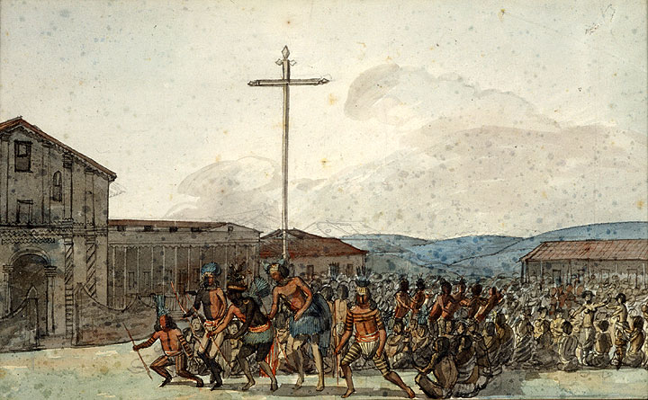
Figure 3. Franciscan Dawn at Mission San Francisco. (1820). Bancroft Library, Berkeley, CA.
It was assumed that the converted natives (called neophytes)—thought of as simple and childlike—would eagerly embrace the Mission. However, their conversion was not accomplished without resistance. Within a month after the establishment of the first mission in San Diego, the Native Americans attacked and the Spanish soldiers fought back with guns. Resistance occurred throughout the Mission period, but the clerico-military administration did not tolerate even non-violent resistance. They responded by sending out armed parties to capture runaways, and punishing runaways with death, hard labor, and flogging (Heizer, 1978).

Life on the Mission
A glimpse of the Mission system makes it is easy to understand why the natives resisted; conditions were brutal. In 1786, Jean Francois Galaup de La Perouse, a French navigator observed, "The Indian Village, consisting of about fifty cabins, which serve as dwelling places to seven hundred and forty persons of both sexes, comprising their children, which compose the mission. These cabins are the most miserable that are to be met among any people; they are round, six feet in diameter by four in height. The men and women are assembled by the sound of the bell. One of the religious conducts them to their work, to church, and to all their other exercises. We mention it with pain, the resemblance so perfect, that we saw men and women loaded with irons, others in the stocks; and at length the noise of the strokes of a whip struck our ears." (Fehrenbacher, 1964).
In contrast to their lives outside, the neophytes performed forced labor in an atmosphere of repression and intolerance. Unlike the slaves in the South at the same time, Native Americans did not work 12 -14 hour days, but the strict regulation of their day ran completely counter to their traditions. With no conception of linear time, it made no sense to them to live or work that way, thus punishments for ignoring routine were frequent and severe. According to Julio Cesar, recalling his life as a neophyte, "When I was a boy the treatment given to the Indians at the mission was not good at all. They did not pay us anything, but merely gave us food and a breechclouth and blanket, the last renewed every year, besides flogging for any fault, however slight." (Glass)
Forced to learn a new language, religion, and etiquette, the Native Americans lost significant social, cultural, and spiritual facets of their lives (Fig. 3). They were accustomed to working together as a tribe and as groups of women or men, but they were forced into a segregated atmosphere, performing solitary work that was more physically demanding than they were accustomed to. Visitors to the mission wrote, "A deep melancholy always clouds their faces, and their eyes are constantly fixed on the ground." (Hemingway, 1996).
During the Mission period, the Native American population declined due to disease and low birth rate. Living primarily on corn or grain gruel, they suffered from inadequate nutrition and were forced to live in crowded, unsanitary conditions that facilitated the spread of European diseases against which they had no immunities (Glass). By 1818, 64,000 Indians had been baptized, and 41,000 were dead (Forbes, 1969).

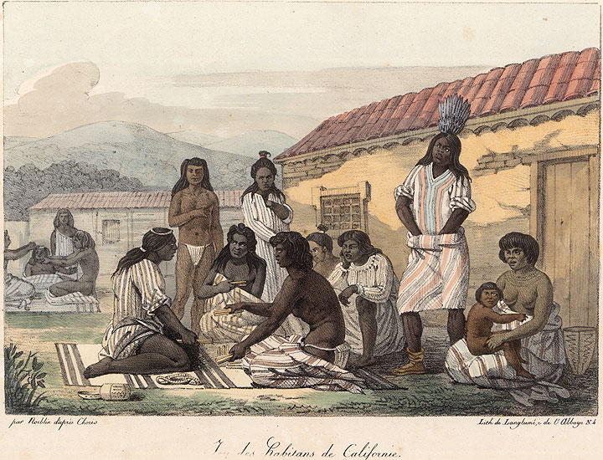
Figure 3. Figure Painting by Louis Choris, Bancroft Library, Berkeley, CA.

Mission Agriculture
In order to produce a self-sufficient community, one of the first things the padres ordered was clearing of the land and planting crops. The padres brought seed with them, and when a new mission was started the other missions sent seeds and livestock to help out. Though the natives had no previous experience at farming, they soon learned to do all of the work on the Mission farms and turned out to be good farmers (Toucan Valley Publications, 2012).
The major field crops at the Missions were wheat (the most important crop), barley, corn, beans, and peas (Jackson, & Gardzina). The Native Americans used wooden plows (made from tree branches with metal points) pulled by oxen to till the land, planted seeds in the furrows, and pushed soil over the seeds with branches. The padres devised irrigation systems that brought water to the fields through stone troughs or adobe clay pipes. The grain was harvested by hand using a sickle, and the stalks were loaded onto a wooden cart pulled by oxen and taken to the threshing area, where horses stomped on the grains to break them away from the husks. Workers then lifted the straw out of the grain with large wooden forks, and winnowed the grain by tossing it in large, flat baskets (Toucan Valley Publications, 2012).
Each Mission planted orchards, vineyards, and vegetable gardens. Trees included orange, lemon, apricot, peach, pear, plum, pomegranate, apple, fig, olive, walnut and almond—most of which had never been grown in California. In the vegetable gardens, the natives grew tomatoes, onions, garlic, melons, potatoes, squash, pumpkins, and peppers. The gardens were surrounded by fences to keep out cattle and wild animals. At Mission San Gabriel, the fence was twelve feet high and formed from prickly pear cactus (Toucan Valley Publications, 2012).
The first cattle, pigs, goats, sheep and oxen were brought to California from Mexico by the padres for the Missions, housing them in corrals made with low adobe brick walls. The Native Americans herders took the animals (branded with the Mission’s own mark) to good grazing places, but were not allowed to consume meat in their diet (Toucan Valley Publications, 2012).
During the first few years, it was difficult for the farms to supply enough food, but later they became self-sufficient and many raised surpluses, which were traded with the presidios and foreign ships for finished goods. Mission San Gabriel was credited with having the most productive farms of the 21 missions (Toucan Valley Publications, 2012). Though the mission storerooms held grains, vegetables, dairy products, fruit and wine, the neophytes were fed an inadequate diet (Glass).
In 1834, as the Mission period ended, records show they owned 296,000 head of cattle, 321,000 hogs, sheep and goats; and 62,000 horses, and had been harvesting 123,000 bushels of grain a year. Just 65 years earlier, there had been no cows, horses, hogs, sheep, goats or wheat in all of California (Toucan Valley Publications, 2012). Farming and cattle grazing had a devastating effect on the native habitat (Jackson, & Gardzina).

The Post Mission Era
Following Mexico's independence from Spain, the Mexican government secularized the missions during 1834-1836 (Forbes, 1969). During this time, the entire economy of the Mexican colony shifted to large, landed estates of wealthy Mexicans (Heizer, 1978). Some Indians survived the Mission era, but their problems did not end. They continued to be hated, persecuted, and seen as slave labor (Hemingway, 1996). While slavery was abolished in the Mexican providence of California in 1829, in 1835 the Indians received a fathom of black, red, and white glass beads for a season’s work (Glass).
Problems continued when California switched from Mexican hands to American in 1846. The attitude of the U.S. was that the natives were a ready slave labor force to be exploited and manipulated. The Native Americans went from being the true owners and inhabitants of California at the time the Missions made their appearance, to being slaves and treated with no more dignity than animals. By the 1890s, the surviving population from the Missions was slashed by another 90%. Seven reservations were thrown together in an effort to protect them, but this was insufficient. In 1928, Congress allowed them to sue for compensation, but the claims of the Mission Native Americans were lumped together into one claim with other Native Americans, and they were forced to accept a meager 47 cents per acre for the lands they lost (Hemingway, 1996).

References:
Archibald, Robert. (1978). Indian Labor at the California Missions; Slavery or Salvation. Journal of San Diego History.
California Missions Resource Center. Map of the California Missions. Retrieved from: http://www.missionscalifornia.com/california-missions-map.html
Choris, L. Figure Painting, Bancroft Library, Berkeley, CA.
Dutschke, D. (2014, October 8). A History of American Indians in California. Retrieved from: http://ohp.parks.ca.gov/pages/1054/files/american%20indians%20in%20california.pdf
Fehrenbacher, D. E. (1964). A Basic History of California. Princeton, N.J.: Van Nostrand.
Forbes, J. D. (1964) The Indians in America's Past. Englewood Cliffs, N.J.: Prentice Hall.
Franciscan Dawn at Mission San Francisco. (1820). Bancroft Library, Berkeley, CA
Glass, F. Native Americans in the Mission Economy. Retrieved from: http://www.foundsf.org/index.php?title=NATIVE_AMERICANS_in_the_MISSION_ECONOMY
Heizer, R. F. (1978). Handbook of North American Indians. Washington, DC: Smithsonian Institution.
Heizer, R. F., & Whipple, M. A. (1971). The California Indians: A Source Book. Berkeley, CA: University of California Press.
Hemingway, H. (1996). From Peace to Present: A Look at the Ohlone Indians. Retrieved from: http://www.mchsmuseum.com/ohlonepeace.html.

Jackson, R. H., & Gardzina, A. Agriculture, Drought, and Chumash Congregation in California Missions (1782-1834). California Missions Foundation. Retrieved from: http://californiamissionsfoundation.org/articles/agriculturedroughtandchumashcongregation/
Mullen, N. (2003). California Indian Food and Culture. Retrieved from: http://www.tongvapeople.org/wp-content/uploads/2016/05/Hearst-Museum-teaching-kit.pdf.
Palmer, S. (2007, February 8). Image: San Gabriel Valley Mission with Anita Oaks School.
Toucan Valley Publications. (2012). Crops and Gardens. Retrieved from: http://factcards.califa.org/mli/cropsandgardens.html

